TRINITY BUILDER


March 2019

Trinity Lutheran Church, Alameda, CA


BURYING THE ALLELUIA

Traditionally, we set aside saying or singing “Alleluia” during the season of Lent. It has become a tradition of many congregations (and of mine) to make a big deal about this Lenten observance on Transfiguration Sunday (the Sunday before Ash Wednesday) and the return of the Alleluia on Easter Sunday. I make a big deal about it because it is a tradition worth observing and worth understanding.
Literally translated, Alleluia means “praise you Yahweh.” In the 14th century, it began being used to mean “above.” Lent is not a time of praise, but rather a time of repentance. It is not about things above, but instead about the earthiest of things – our mortality; dying and rising; sin and imperfection.
The praise of “Alleluia” becomes a stark contrast on Easter morning as we are confronted with the least grounded of stories, the story that Jesus is risen, and we shall be raised! The Alleluia is sweeter; the praise becomes an outpouring of our new-found freedom. This is because we have journeyed through a season turned inward looking for good news amidst the stark reality that we are not the gods we have imagined ourselves to be. Lent restores our perspective about how great our God is and how grateful we are.
Please don’t miss our special ritual of burying the Alleluia on Sunday, March 3. It’s a tangible way we begin this Lenten journey together.
Blessings,
Pastor Stephanie
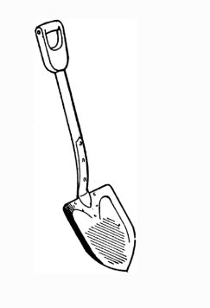

Our Lenten journey continues on Ash Wednesday and through the 40 days of Lent. You are encouraged to take part in our Lenten observances. See Page 2

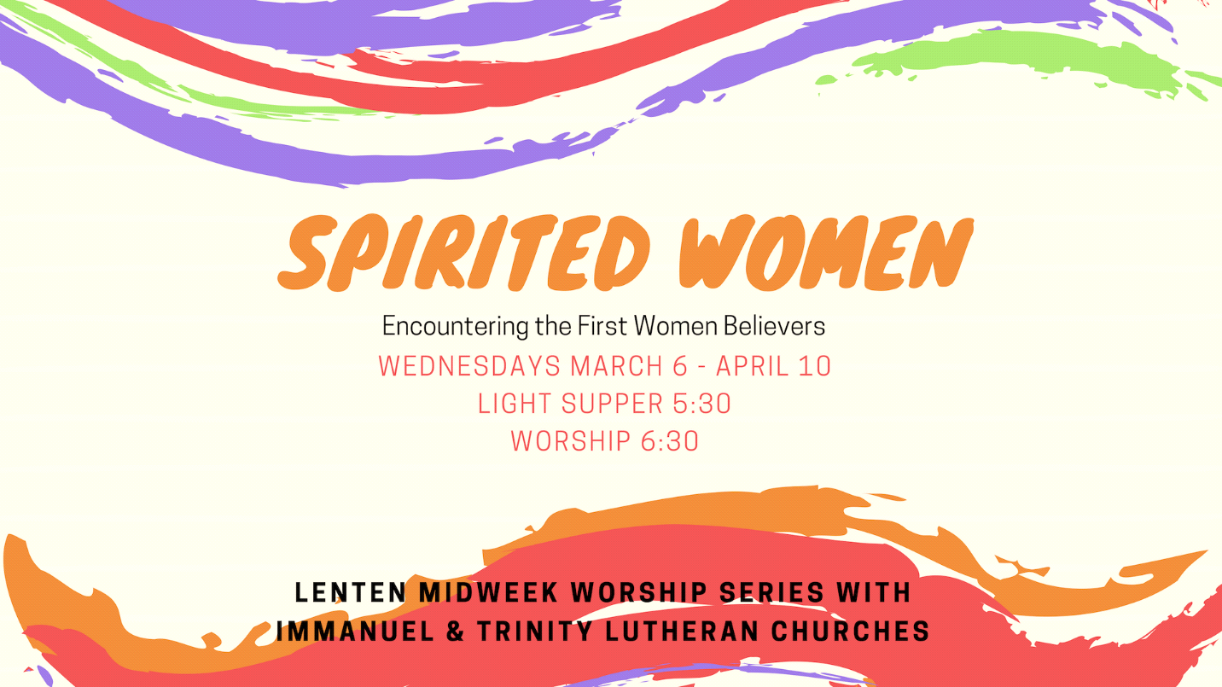

This year Trinity and Immanuel Lutheran Churches will worship together for our mid-week Lenten services as well as for our Holy Week and Ash Wednesday services. Pastor Dot Lundgren and Pastor Stephanie Johnson are looking forward to sharing this experience together with you, our congregations. As is the custom for both of our congregations, we will host a light supper prior to worship and then will worship together with Holden Evening Prayer when we are at Trinity and with an equally contemplative service when we are at Immanuel. We encourage you to come and be fed with this series.

March 6 Ash Wednesday Noon Trinity
7:00 p.m. Immanuel
March 13 Mary Magdalene 5:30 p.m. Supper at Trinity
6:30 p.m. Worship at Trinity
March 20 Maria 5:30 p.m. Supper at Immanuel
6:30 p.m. Worship at Immanuel
March 27 Mary, the Mother of Jesus 5:30 p.m. Supper at Trinity
6:30 p.m. Worship at Trinity
April 3 Joanna 5:30 p.m. Supper at Immanuel
6:30 p.m. Worship at Immanuel
April 10 The Samaritan Woman 5:30 p.m. Supper at Trinity
6:30 p.m. Worship at Trinity
April 18 Maundy Thursday 6:00 p.m. Dinner at Immanuel
Martha 7:00 p.m. Worship at Immanuel
April 19 Good Friday Noon Immanuel
7:00 p.m. Trinity

COFFEE HOUR IN HONOR OF BERTIE SALISBURY
After more than 35 years, our beloved Bertie Salisbury has retired from childcare at Trinity. On Sunday, March 3, we will celebrate her with a coffee hour in her honor after the 10:30 worship service. This will be a potluck event, and we invite you to bring a finger food of some sort for coffee hour. Cake, punch, and coffee provided. Cards are welcome.



BABY “SPRINKLE” FOR LINDSEY MODER
Mary James
I have it on very good authority that a baby shower for a second baby is called a “Sprinkle,” and that is what we will have at our coffee hour on March 10 as we celebrate our expectation of another Moder baby boy!
What a great delight to look forward to this new addition to our faith family! Any contributions either to enjoy at the party or for the baby boy later are most welcome. I will have a sign -up sheet in the narthex so we can see what is coming (and figure out what more might be needed!). I haven’t planned a “Sprinkle” recently, so if you have ideas to add to this, please let me know.



LUCK OF THE LUTHERANS: ELCA WORLD HUNGER
Mary James
This year our “Luck of the Lutherans” event will be on Sundays March 10 and March 17. We are so very fortunate to have a powerful and effective ELCA Hunger Program. While we are often troubled by news of hunger issues both nationally and globally, a lot of unnecessary suffering is considerably reduced or prevented through our ELCA Hunger Program, which makes it possible for our church to respond and provide sustainable solutions that get to the root causes of hunger and poverty. Sharon Magnuson from the ELCA Hunger Program will be here on Sunday, March 17. She will be sharing some of the latest very good news of this program in our adult Sunday School class that morning at 9:00 a.m.
And our good fortune this year includes $500.00 in matching funds from some anonymous donors. Checks to support this program should be made out to Trinity with “World Hunger” in the memo field.
If you would like any further information on the exciting potential we can know in relief, development, education, and advocacy with regard to our ELCA World Hunger program, please join us in the adult Sunday School on March 17. You can also check it out at http://www.elca.org/en/Our-Work/Relief-and-Development/ELCA-World-Hunger/Our-Approach. Many thanks for your faithful support of this amazing ministry!



TRINITY BOOK CLUB MEETING

The next Trinity Book Club meeting is scheduled for Tuesday, March 12 at 7:30 p.m. For discussion at this meeting, we picked Bishop Michael Curry's The Power of Love: Sermons, reflections, and wisdom to uplift and inspire. The Dows will provide some refreshments.

FORUM ON ALAMEDA WELLNESS CENTER
Trinity Lutheran Church will be hosting a discussion on Saturday, March 16, from 10:00 a.m.-noon to learn more about the Alameda Wellness Center and special election to be held April. The Alameda Point Collaborative has plans to repurpose surplus federal buildings to serve the most fragile in our community – homeless elders, homeless patients requiring aftercare, and Alamedans at risk of losing their housing or recently homeless. The mission of the Alameda Wellness Center is simple: improve the quality of life of seniors who are medically frail and living on our streets.
Come to the discussion to learn about the special election to be held on Tuesday, April 9. For more information about the Wellness Center, go to www.wecarealameda.com or www.caringalameda.org. For the wording of Measures A and B, go to www.alamedaca.gov. Also talk to Kathy Booker or a member of the Mission and Service Committee if you have any questions. Hope to see you there.



CRAB FEED FUNDRAISER


Saturday, March 30 6:00 p.m.
$50.00 per adult
$20.00 per child age 12 and under
The Crab Feed will feature crab, potato salad, green salad, bread, dessert, and wine (extra charge). Chicken will be available for those who do not want crab. There will also be a raffle, with raffle tickets available at the Crab Feed. Proceeds will be divided between the EBLYP and Trinity's 2019 general fund.



MUSIC MINISTRY UPDATE
Julie Haydon
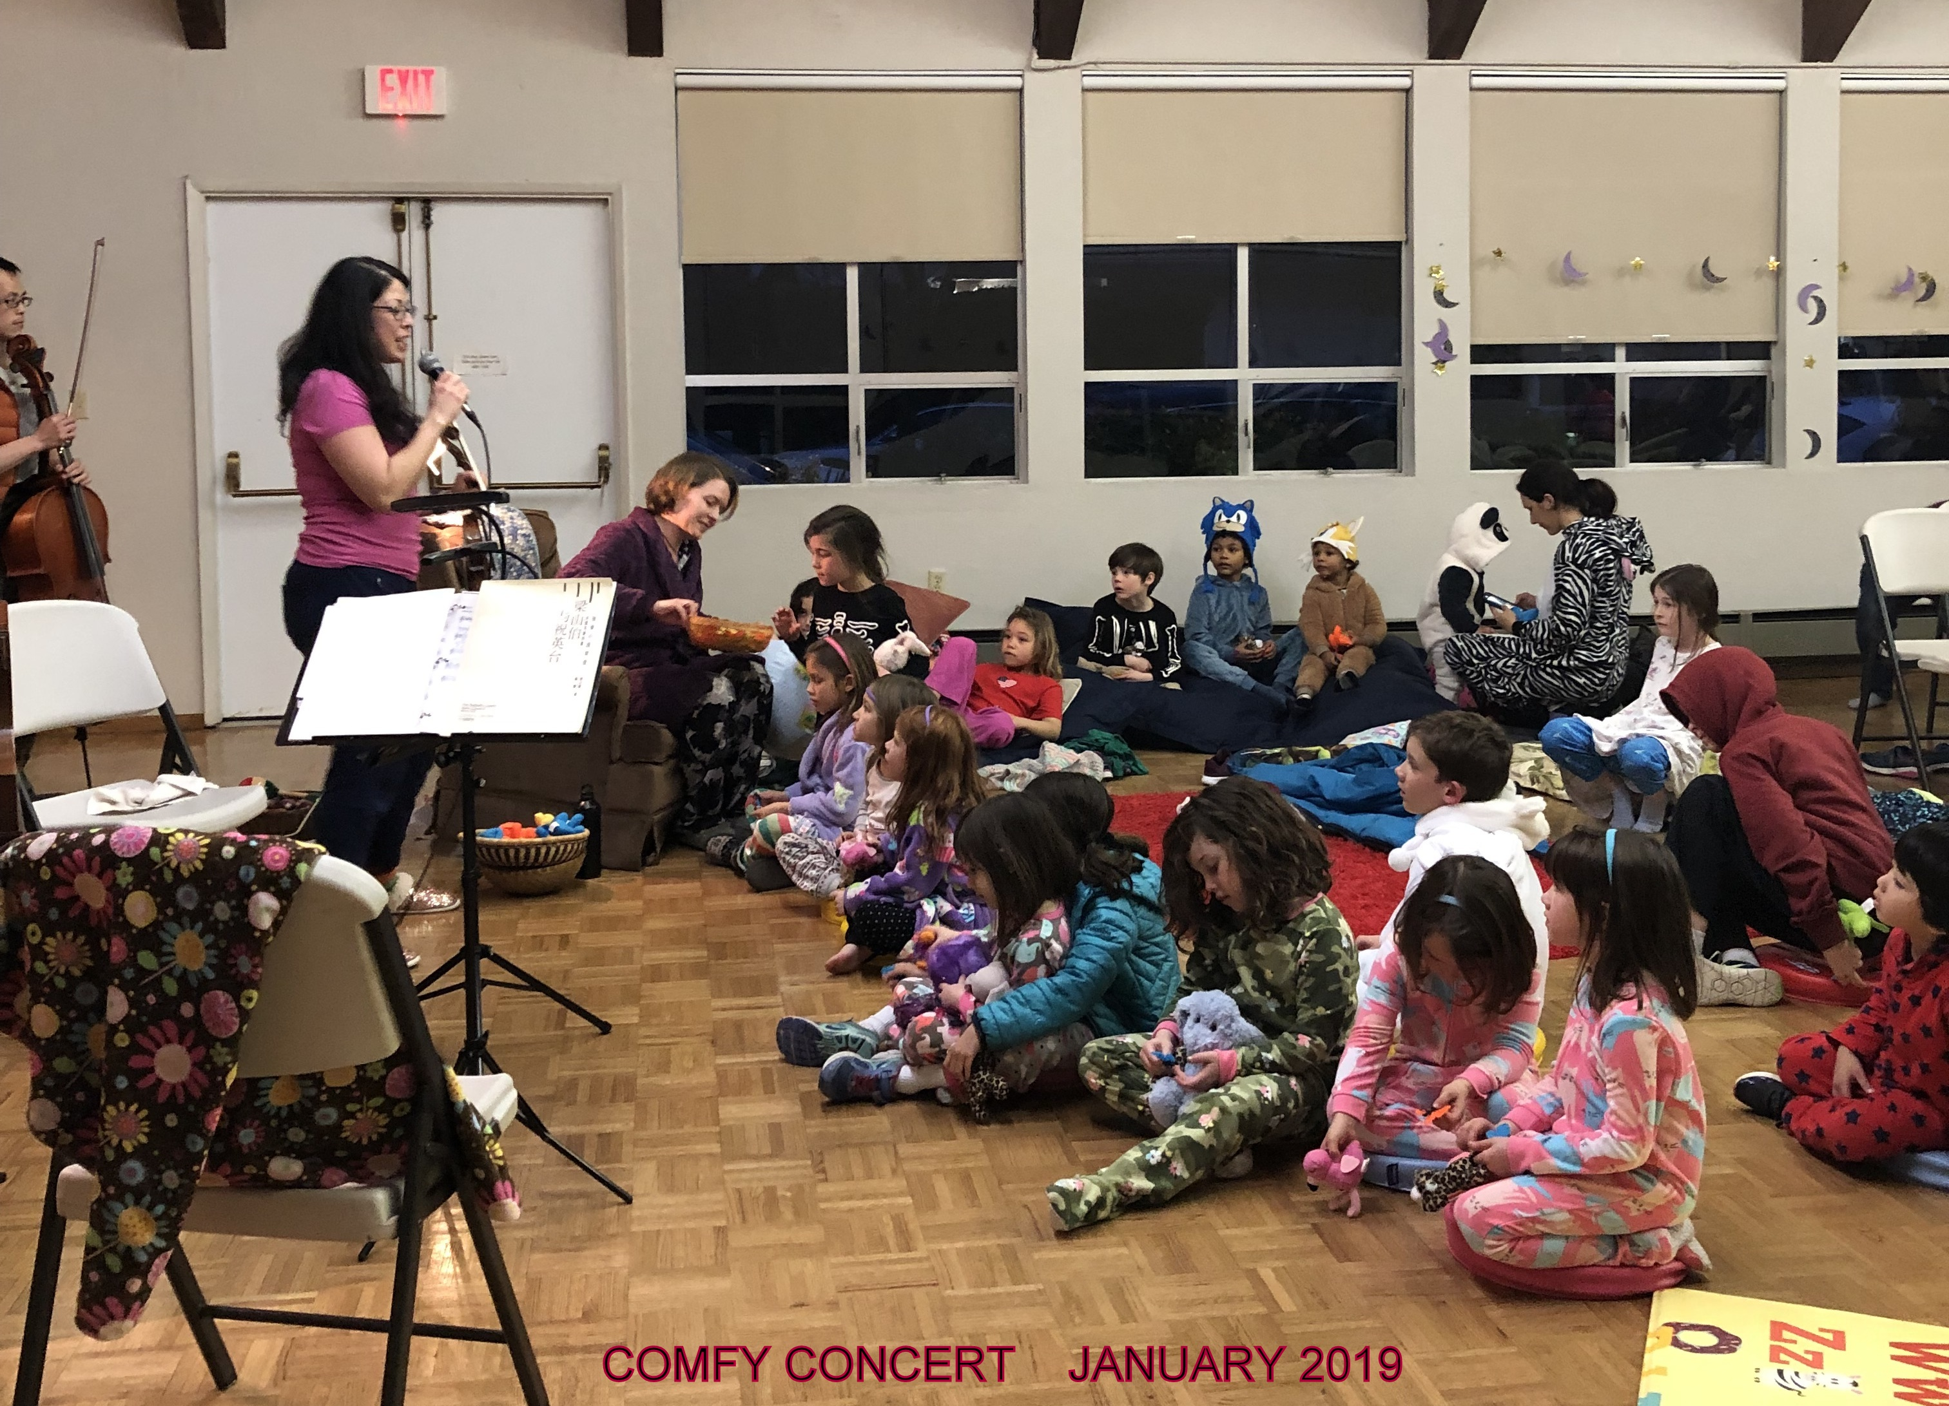
We had a great time last month at the Comfy Concert, offered in collaboration with Alameda String Academy and Comfy Concerts. Over 40 children and their families came and listened to an outstanding program presented by ASA faculty. It was wonderful to see the Fellowship Hall packed with families and to see the kids enjoying their introduction to chamber music. Special thanks to all of the volunteers who helped make this a fun evening.
Singing Bells: In the bell choir, we are enjoying the chance to incorporate special techniques in our playing. One of these techniques is called a "singing bell." Instead of ringing the bell as usual, the players use a stick to move around the outside rim of the bell to create a light hum. The effect is really enchanting, especially with a whole group playing! Next month, the bell choir will have a special clinic with an incredible ringer and musician, Erin Downey, who will work with us to refine our technique and inspire us with new ideas. If you have been thinking about ringing bells, come join in the fun!
MUSIC MINISTRY EVENTS - Mark your calendars:
Sunday, March 3: The Nova Youth Choir from Cantare Con Vivo (directed by Julie Haydon) will perform a free concert in the sanctuary at 4:00 p.m., including beautiful choral works and a set of Beatles tunes for you to sing along with.
Easter Sunday, April 21: The choir and bells will offer special music at 8:00 a.m. and 10:30 a.m. with a guest trumpet player.
Spring Concert Sunday, May 5: Children from the Joyful Noise Community Choir will perform a free concert for the community at 3:00 p.m.
Music Ministry Sunday, May 19: The choir and bells will offer special music during the 10:30 worship service, accompanied by guest musicians.



GROW DEEPER BIBLICAL ROOTS!
Deepen your faith journey by adding a Bible study or faith formation group to your week.
There are four to choose from and more are the works!

ADULT FAITH FORMATION CLASS SUNDAY MORNINGS
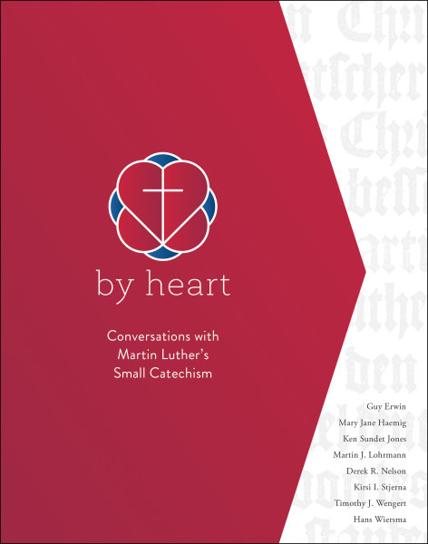
You’re invited into conversation about the Small Catechism as we continue to explore By Heart: Conversations with Martin Luther’s Small Catechism, a multi-session course designed to explore the biblical and historical context of the Small Catechism, its link to the church’s faith, and its connection to Luther’s life and your life today. Our conversation resumes March 10 with The Apostles’ Creed. Purchase your participant’s guide, By Heart: Conversations with Martin Luther’s Small Catechism, for $15 from Amazon or Pastor Stephanie.
The Adult Faith Formation Class meets in the meeting room next to the Pastor’s office each Sunday from 9:00 –10:00 a.m., except the first Sunday of the month when we encourage you to join us for the Early Coffee Hour.

Tuesday morning Bible study
A group of early risers meets on Tuesday mornings at 7:15 a.m. in the meeting room throughout the year. This group studies the Bible readings for the coming Sunday.

Deep Thoughts with Pastor Stephanie
March 18 and 25 from 7:30-9:00 p.m.

This discussion group meets the third and fourth Mondays of each month in the meeting room. This month we continue the series Animate: Faith. Each session has a video component, a conversation time, and something to chew on when you leave. We’ll hear from dynamic presenters about the following topics: God, Religion, Jesus, Salvation, Cross, Bible, and Church. You can get your participant guide from Pastor Stephanie. $15 suggested donation.

Women's Bible Study
We welcome women to join the Women’s Bible Study at 10:00 a.m. on Wednesdays in the meeting room. This month we will continue our study of the Gospel of Mark.





Pastor Craig Minich

EBLYP Annual Mardi Gras Fundraiser
On Saturday, March 2, at Trinity -Alameda (1323 Central Ave.), come celebrate the precursor to Lent with this festive dinner party that benefits the EBLYP. We serve a delectable NOLA inspired dinner and have a fun silent auction and a spirited live-auction as well. There will be a happy hour (where you can buy alcohol for the evening), live music, youth performances, and cupcakes from Spun Sugar!
Tickets are $50/person (this is a fundraiser!). That said, we do have some sliding scale tickets available as well. Tables of 8 can be reserved for a $25 discount. Tickets can be purchased online at Eventbrite, or contact Jessica Fleischman at trinityalameda@gmail.com or call her at 510.812.4752.
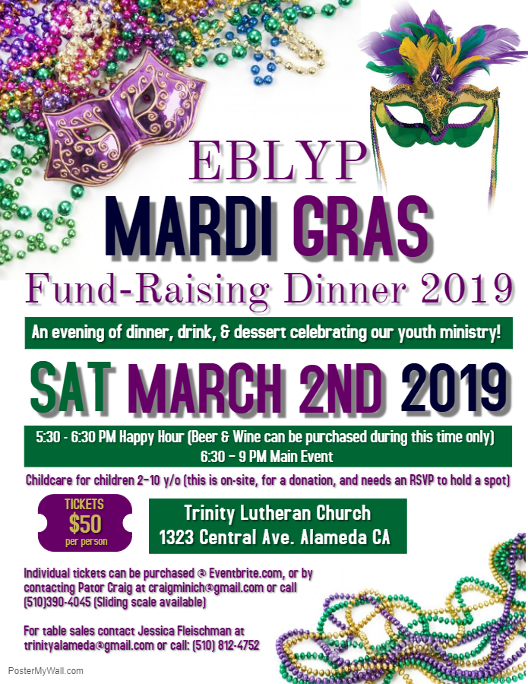

EBLYP Family Ministry - for EBLYP families and friends
Our Family Ministry held our annual All-Youth Group “Bowled Over by the Spirit” Epiphany Party at Mel's Bowl in Alameda on Sunday, January 6. This event is co-sponsored by Trinity-Alameda, and we served festive treats and beverages. We marked the celebration of Epiphany by praying in “lane groups” after each game that we bowled. In Epiphany we are bowled over by the spirit of Jesus moving in our lives; we remember our baptisms and celebrate the spirit joyfully bowling us over as it did with Jesus in his baptism.
Next Family Ministry Events:
Kids' Mardi Gras party at Trinity - Alameda on Saturday, March 2, from 5:30-9:00 p.m. Please contact Pastor Craig to reserve a spot. There is a nominal fee of $10 for this party. Dinner is included.
Parents' Night Out (PNO) Babysitting Fun Night at St Paul Lutheran Church (1658 Excelsior Ave., Oakland) from 6:00-9:00 p.m. on Friday, March 29. Kids are fed dinner; we pray and sing, play games, do a craft, and watch a movie with hot chocolate and popcorn as treats. Cost is $25 for 1 child, $35 for 2 siblings, and $45 for 3 or more siblings. RSVP for this event with Pr. Craig at craigminich@gmail.com or 510.390.4045 by Mar. 20.
G.E.T. (God's Elementary-people Together) - our upper elementary youth group
We had 10 youth and a few of their parents attend our annual Epiphany Bowling Party January 6. We were “Bowled Over by the Spirit” as we knocked over those pins! We also prayed that the Holy Spirit would guide us in God's good Grace before and after our game!
NEXT G.E.T. MEETING will be held on Sunday, March 3, from 12:30-2:00 p.m. at St. Paul Lutheran (1658 Excelsior Ave, Oakland). Each family is asked to bring a drink and snack to share.
EBLYP (continued)
MYLK (Middle Youth, Lutheran Kids) - our 6th - 8th grade youth ministry
Our MYLK and SNL 8th and 9th graders began the new confirmation class at our first confirmation sleepover of the program on Feb 8-9. There are four students from St. Paul Lutheran: Chewy, Elsa, Iris, and Amalie; one student from Resurrection Lutheran: Hanna; and one student from United Lutheran: Ivonna. We began to build community, learned our first lessons, prayed together, and took part in our first service learning project: visiting residents at Crown Bay Health Care Center in Alameda (see Mary James' article, page 9). We brought Valentine’s Day cards, we sang, and we talked with the residents. Our youth are excited to begin this faith journey!
Next MYLK events:
We are asking all of our MYLK youth to either be servers at the EBLYP's annual Mardi Gras Dinner and Fundraiser on Saturday, March 2, or to help with set-up on Saturday morning, March 2, from 11:00 a.m.-1:00 p.m. Pizza and beverages will be provided. You can come to both if you really want to!
Our annual Snow Retreat, originally scheduled for February 1-3, needed to be rescheduled due to treacherous driving/weather conditions that weekend. Our new date for this Retreat is April 5-7, and it will be held near Northstar Resort. We are VERY excited to experience God's grace in all that new snow!!! Please note this new date and RSVP for this event with Pr. Craig at craigminich@gmail.com or 510.390.4045.
Our next regular MYLK meeting is Sunday, March 24, from 12:30-2:00 p.m. at St. Paul Lutheran.
SNL (Sunday Night Live) - our 9th - 12th grade group
Our SNL youth attended the Senior High Synod Weekend Retreat, February 24-26, at Mt. Cross. We explored the Bible verse: "The Light shines in the Darkness" - John 1:5 and learned about the sacred spiritual system of the enneagram to better understand and love ourselves and to help us be better neighbors. There was a prayerful dance that we lovingly called a “prayer rave,” and we also had moving prayers around the cross by candlelight. It was a powerful retreat, and our community bonded deeply on this mountaintop experience. We also held elections for a new year of service on SPSYC. Chase Beardsley from Trinity - Alameda was elected as the new president of this committee. Olivia Tyreman from St. Paul was re-elected to the committee after a one-year break. Sophia Hofmann from Trinity - Alameda continues to serve out her second year of a two-year term as youth representative to the Sierra Pacific Synod council. We are very proud of our young leaders, and we celebrate our leaders who are finishing up this year's term: Kylie Halmi, Kiki Valenzuela, Joanna Ruiz, and Maggie Werner. Well done, good and faithful servants!
Summer Trip 2019: Please pray for us as we fine-tune the details of our trip to New York City where we will be participating in original youth group written prayer services at 4-5 iconic and meaningful sites, making connections to the stories of our faith and their relevance for us today. We, of course, are also planning service opportunities in the city and will take in other cultural and festive activities while we are there.
NEXT SNL Events:
We are asking all of our SNL youth to be servers at the EBLYP's annual Mardi Gras Dinner and Fundraiser on Saturday, March 2.
Rescheduled Snow Retreat: See MYLK events above
Our next regular SNL meeting is Sunday, March 24, from 4:30 to 6:00 p.m. at St. Paul Lutheran (1658 Excelsior Ave, Oakland). Please bring a drink and snack to share.

Mental Health concerns in our youth
I have been noticing increased levels of anxiety in our high school youth over the past two years. In response, our youth ministry has offered Phase One responses in Suicide Prevention trainings and Mental Health First Aid trainings. As we look into a Phase Two response, I have been working with the Christian Education Committee at Trinity Lutheran in Alameda, which has developed a survey to help us collect data to guide that response. We look forward to reporting on our findings next month. We continue to minister to our youth struggling with anxiety and depression, and we ask for your prayers for all youth in our churches and in our communities facing these challenges.

Surprised By Joy at Crown Bay
Mary James
Six youth from the EBLYP, Pastor Craig, and I visited Crown Bay Nursing Home on February 9 with hopes of being blessings there. God had bigger plans, and my toes still tingle thinking about it.
The youth who were able to come (straight from an overnight event at St. Paul) included Amalie, Iris, Elsa, Hanna, Charlie, and Cecil. They came ready with valentines that they had made to share. We gathered to explore thoughts and pray before starting our visits….and then God let us have it.
One of our first visits was with a woman named Mary, who told us several times that she was 92 and that in her lifetime she had never seen God forsake the righteous. She was reading Psalm 37 when we came in, and her message was right from verse 25 of that Psalm, which we then read with her.
In several of our visits we sang “This Little Light of Mine” and were delighted to often have residents join in. After we visited Bruce, we later heard him singing that song as we were walking down the hall. What a special treat that was.
We also had a delightful visit with Eva Fields who looked so radiant that I took a picture of her with our group. She told us the inspiring story of a time when she had visited people at Crown Bay with her dog, Ginger. On one of those visits when Ginger put her head in a woman’s lap, that woman slowly put her hand on Ginger’s head. The woman’s husband and the nurses were stunned because she hadn’t moved at all in a year due to a major stroke. That woman’s recovery really progressed after the time with Ginger.
Another resident, Dawn, was being visited by her brother Chuck from Yuba City who was planning to move to this area to help her. Turns out that he is Lutheran and asked about our church.
Our last visit was with another woman named Mary and when we sang “This Little Light of Mine” with her, she then taught us 2 more verses!
We had planned this time with the hopes of being blessings to the people we met there. And that truly happened, but God’s bigger plan was what an incredible time of blessing it was for us, too. In our reflections afterwards, there were many comments on the joy that we experienced there.

CHURCH PLANTING IN KENYA 2019
Mary James
As you may have heard, I am going to Kenya again as part of the church planting program that I was part of last June. It was such an amazing delight to share the Good News with people who really wanted to hear it! They cared about their relationship with God and were willing to spend time talking with me and chose to trust Jesus. And the joy of seeing the church building (which had no congregation the Sunday before) full of life on Sunday, July 1, 2018. Wow!
This year the trip is June 22-July 3. I will again be going with a team that is based near Portland, Oregon: the Chehalem Christian Fellowship with my very dear friends, Phil and Denise Norby. This will be their 20th church planting trip.
Like last year, we hope to have a team of 20 to 25 going. We will be doing house-to-house evangelism in the area around the location of the church building and at several schools and at prisons in that area.
I would appreciate your prayers: for peace to continue in Kenya; for safety to travel to Africa; for our days in the field, going door-to-door, and at rallies in schools and prisons. Churches that were previously planted in Kenya will assist us by sending their musicians and vocalists for worship opportunities. Their pastors and members will assist in translation from English to the local languages.
I would also appreciate your prayers in raising support. There is the requirement for me to gather my own support group - friends and family who will be praying for me and providing financial support as they are led. While I can cover the cost of this trip, I have been directed to encourage my support group to chip in as they are able, as a point of connection to this God adventure. Asking for financial support is my least favorite part of this adventure, but I did really enjoy letting my new friends in Kenya know that there was a large team of people who had helped me to come. I wore a necklace on which I had a tied piece of ribbon with the name of each person giving me support. It was a fun visual emphasizing the work of the Holy Spirit bringing us together in support of this work. That made an impression on them.
I’d really love to share more about this mission with you. And, if you have an opportunity, please visit Chehalem Christian fellowship.org/Kenya. Please let me know if you have any further questions.

FEBRUARY COUNCIL MEETING NOTES

Pastor Stephanie’s report
Our Sunday morning adult faith formation class is currently using By Heart, a study in Martin Luther’s Small Catechism. This class is a wild success. We have up to 18 people who join us for our discussions. I think this indicates both a hunger for learning about our faith and a specific curiosity about the Small Catechism.
On Sunday, March 3, we will recognize over 35 years of Bertie Salisbury’s service to the nursery. She announced on January 27 that she was retiring.
The website is almost ready to “go live.” I’m still working on the content, but Patrick Fleischman has worked out the bugs that were keeping me from being able to do that.

Committee Reports
Property: The stove fire suppression system and the fire extinguishers have been serviced. Karol Luque recommended that we use the same company for servicing both the stove system and the fire extinguishers. She will see that this happens when the fire extinguishers need to be serviced next year.
The parsonage roof leaked in the last rainstorm. John Kofranek patched where it was leaking.
As of January 31, we have received donations totaling $15,430 of the total cost of the 2018 roof project ($24,041.33).
Old/New Business:
The council approved the housing allowance of $3000, which Pastor Stephanie requested. This money is tax free to her. The housing allowance is requested by the pastor and approved yearly by the council.
The Mission and Service Committee would like to host a forum on March 16 for discussion of the Alameda Wellness Center, the existence of which will be decided by special election on April 9. Doug Biggs from Alameda Point Collaborative will speak on Measure A. Pastor Stephanie and Jessica are seeking a person who could speak about Measure B as well. Because of some problems at a similar forum at Christ Episcopal Church, the forum may or may not be open to the public. The council will vote on this by email after Jessica has collected more information.
The council approved the Fellowship Committee’s request that the proceeds from the 2019 Crab Feed be split between the EBLYP and Trinity’s general fund.
There was a discussion of council positions that are up for election at the May congregation meeting. Anita Burnaford and John Kofranek are terming out this year (having served two 3 year terms), and the remainder (1 year) of Mark Schoenrock’s vacated position needs to be filled. The terms of 4 other council members also expire this year, but they are eligible to serve again. Candidate nomination forms will be included in the Sunday bulletin on March 24, 31, and April 7.
The date of the regular April council meeting falls on Maundy Thursday this year. The council agreed to move the April meeting to April 11.
The next council meeting will be March 21.

FOOD BANK SUNDAY
Our next Food Bank Sunday is March 10. There is a barrel in the fellowship hall or narthex in which to put your non-expired, non-perishable food donations. Please continue to help to support the Alameda Food Bank.


SECOND MILE GIVING

ELCA Campus Ministry
ELCA campus ministry is a Lutheran ministry for students, faculty, staff and others on campus, not just a ministry for Lutherans. It provides an ELCA presence at more than 180 state and private colleges and universities with cooperating congregations in campus ministry at an additional 400 campuses nationwide. Through worship, study, fellowship and service, members of the academic community taste the fullness of God’s grace. As expansive as Christ’s love, campus ministry reaches out to all who teach and learn, inviting them to experience the challenge of following Jesus.



MARCH BIRTHDAYS


1 Nancy Leavitt
1 Craig Minich
5 Craig Blyeth
5 Chris Laine
5 Antonio Ruiz
7 Helen Pedersen
11 Elizabeth Madaras
11 Dorothy Wingire
15 Stevie O’Connell
19 Mike Luque
21 Jackson Bohm
21 Karen Haines
26 Bob Abbe
26 Lou O’Connell
29 Judy Lamb
31 Catie Norboe
31 Susan Widule



Trinity Builder is a monthly publication of  Trinity Lutheran Church  1323 Central Avenue, Alameda, CA 94501  510-522-5220  Pastor: Rev. Stephanie Johnson  Nursing Home Ministry Pastor: Rev. Ned O’Donnell  Youth Pastor: Rev. Craig Minich  Council President: Anita Burnaford  Organist/pianist: Starr Brown  Director of Music Ministry: Julie Haydon  Custodian: Martin Kelly  Groundskeeper: Martin Kelly  Office manager: Jessica Fleischman  Builder editor: Marilyn Ohm-Smith | Trinity Church Council (Ministry Area Liaisons)  President: Anita Burnaford-19 (Stewardship, Worship & Music)  Vice President: John Kofranek-19 (Property)  Secretary: Mike Luque-19 (EBLP)  Recording Secretary: Jessica Fleischman  Treasurer: Mark Schoenrock  Pastor: Rev. Stephanie Johnson  Chase Beardsley-19  Nick Hayes-20 (Mission & Service)  Karol Luque-20 (EBLYP, Worship & Music)  Elizabeth Madaras-20 (EBLP, Fellowship, Finance)  Henry Mills-19  Margie Sherratt-20  Mary Kay Wentz-19 (Trinity Seniors, Visual Enrichment)

